Practical 10
Using Smoke Sensors with Raspberry Pi

To detect smoke/gas using an MQ-series smoke sensor module with Raspberry Pi 3 and display the status using LED + buzzer (optional), and print readings on the terminal.

Smoke Sensor
A Smoke Sensor (MQ-series) is used to detect smoke and harmful gases in the air. Sensors like MQ-2 and MQ-135 work by sensing changes in resistance when gas or smoke is present.
When clean air is present, the sensor gives normal output. When smoke or gas is detected, the output changes, which can be read by the Raspberry Pi through the digital (DO) pin.
Smoke sensors are widely used in fire detection systems, gas leakage detection, and air quality monitoring to ensure safety and prevent accidents.

Components Required
- Raspberry Pi 3 + SD card + RPi OS
- MQ-2 or MQ-135 gas/smoke sensor module (with AO + DO pins)
- LED + 330Ω resistor
- (Optional) Buzzer
- Jumper wires + Breadboard

Pin Connections
Smoke Sensor Pin | Raspberry Pi Physical Pin | GPIO Numbering
VCC | Pin 2 / 4 | 5V
GND | Pin 6 | Ground
DO | Pin 11 | GPIO17

| Smoke Sensor Pin | Raspberry Pi Physical Pin | GPIO Numbering |
|------------------|--------------------------|----------------|
| VCC | Pin 2 / 4 | 5V |
| GND | Pin 6 | Ground |
| DO | Pin 11 | GPIO17 |

LED
LED / Buzzer | Raspberry Pi | GPIO Numbering
- long Leg / + terminal | Pin 13 | GPIO27
- Short leg / - terminal | Pin 14 | Ground

| LED / Buzzer | Raspberry Pi Pin | GPIO Numbering |
|-------------------------------|------------------|----------------|
| Long leg / + terminal | Pin 13 | GPIO27 |
| Short leg / - terminal | Pin 14 | Ground |
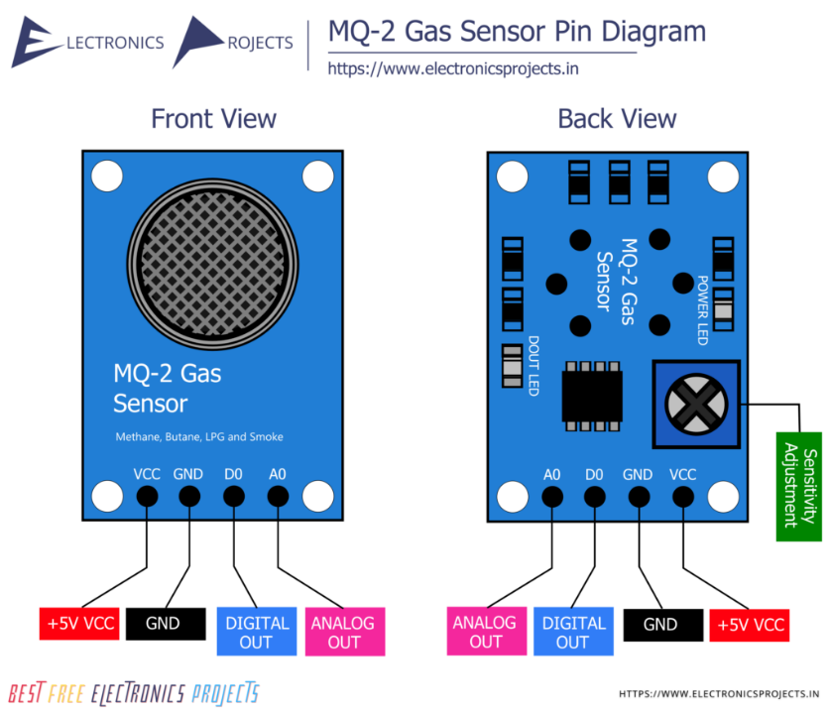
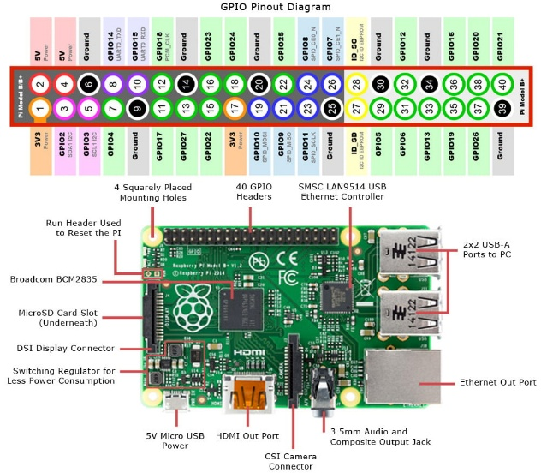

Code: -
import RPi.GPIO as GPIO
import time

SMOKE_DO = 17 # MQ module DO pin connected to GPIO17
LED_PIN = 27 # LED connected to GPIO27
#BUZZER_PIN = 22 # Optional buzzer

GPIO.setmode(GPIO.BCM)
GPIO.setup(SMOKE_DO, GPIO.IN) # Digital output from sensor
GPIO.setup(LED_PIN, GPIO.OUT)
#GPIO.setup(BUZZER_PIN, GPIO.OUT)

print("Smoke Sensor (MQ) is warming up... Please wait 20 seconds")
GPIO.output(LED_PIN, GPIO.LOW)
#GPIO.output(BUZZER_PIN, GPIO.LOW)
time.sleep(20)

print("System Ready")
print("Monitoring smoke/gas... (Press CTRL+C to exit)")

try:
while True:
# DO = 0 when smoke/gas is detected
smoke_detected = (GPIO.input(SMOKE_DO) == 0)

if smoke_detected:
print("SMOKE/GAS DETECTED!")
GPIO.output(LED_PIN, GPIO.HIGH)
#GPIO.output(BUZZER_PIN, GPIO.HIGH)
else:
print("Air is clean")
GPIO.output(LED_PIN, GPIO.LOW)
#GPIO.output(BUZZER_PIN, GPIO.LOW)

time.sleep(1)

except KeyboardInterrupt:
print("\nExiting... Cleaning up GPIO")
GPIO.cleanup()

Output: -
